Chapter 15, Solution 13.

(a) 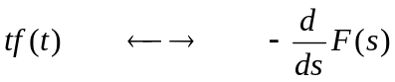
If f(t) = cost, then 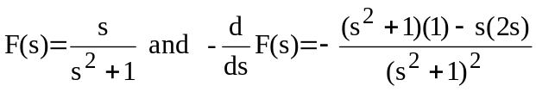

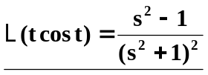

(b) Let f(t) = e^{-t} sin t.

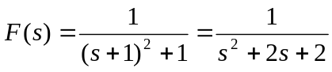
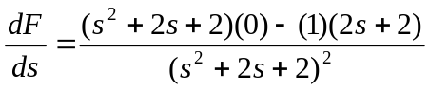
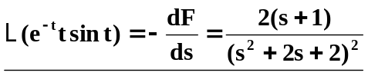

(c ) 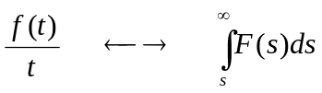

Let 